LMSYS - Chatbot Arena Human Preference Predictions
Overview
This competition challenges you to predict which responses users will prefer in a head-to-head battle between chatbots powered by large language models (LLMs). You'll be given a dataset of conversations from the Chatbot Arena, where different LLMs generate answers to user prompts. By developing a winning machine learning model, you'll help improve how chatbots interact with humans and ensure they better align with human preferences.
Description
Large language models (LLMs) are rapidly entering our lives, but ensuring their responses resonate with users is critical for successful interaction. This competition presents a unique opportunity to tackle this challenge with real-world data and help us bridge the gap between LLM capability and human preference.
We utilized a large dataset collected from Chatbot Arena, where users chat with two anonymous LLMs and choose the answer they prefer. Your task in this competition is to predict which response a user will prefer in these head-to-head battles.
This challenge aligns with the concept of "reward models" or "preference models" in reinforcement learning from human feedback (RLHF). Previous research has identified limitations in directly prompting an existing LLM for preference predictions. These limitations often stem from biases such as favoring responses presented first (position bias), being overly verbose (verbosity bias), or exhibiting self-promotion (self-enhancement bias).
We encourage you to explore various machine-learning techniques to build a model that can effectively predict user preferences. Your work will be instrumental in developing LLMs that can tailor responses to individual user preferences, ultimately leading to more user-friendly and widely accepted AI-powered conversation systems.
Evaluation
Submissions are evaluated on the log loss between the predicted probabilities and the ground truth values (with "eps=auto").
Submission File
For each id in the test set, you must predict the probability for each target class. The file should contain a header and have the following format:
id,winner_model_a,winner_model_b,winner_tie
136060,0.33,0,33,0.33
211333,0.33,0,33,0.33
1233961,0.33,0,33,0.33
etc
Code Requirements
This is a Code Competition
Submissions to this competition must be made through Notebooks. In order for the "Submit" button to be active after a commit, the following conditions must be met:
- CPU Notebook <= 9 hours run-time
- GPU Notebook <= 9 hours run-time
- Internet access disabled
- Freely & publicly available external data is allowed, including pre-trained models
- Submission file must be named submission.csv
- Submission runtimes have been slightly obfuscated. If you repeat the exact same submission you will see up to 15 minutes of variance in the time before you receive your score.

1st Place Solution
Introduction
I am thrilled to have won first place in this competition, marking my first solo gold medal🏅. I would like to thank Kaggle and the organizers for hosting this competition. Despite the leakage issues that troubled many participants, I appreciate Kaggle's efforts to salvage the competition as much as possible. In my view, the CV and LB in this competition were very consistent, making it a rare and excellent contest, especially in the current context of LLMs. 🔥 Next, I will summarize my solution.
Solution
Dataset
kaggle train data ut data(https://www.kaggle.com/competitions/lmsys-chatbot-arena/discussion/499756) 33k data (https://www.kaggle.com/competitions/lmsys-chatbot-arena/discussion/500973)
Base models
llama3 70b qwen2 72b gemma2-9b
Base model architecture
AutoModelForSequenceClassification lora(9b) qlora(llama3 and qwen2) all linear for lora r=64,a=128 max_len=1024 epoch = 2 global batch_size = 64
Post-pretrain
To begin with, train one epoch on three models using the ut dataset. （lr=1e-5）
Get the logits distribution
Load the weight from Post-pretrain, split the dataset into 5 folds for training (eg:train➡️4/5 kaggle train data + 33k data,dev➡️1/5 kaggle train data) to train llama3 70b and qwen2 72b. Then infer the probability distribution of the training set.
Distill to the 9b model with logits
After obtaining the logits distribution, load the 9b model for fine-tuning and incorporate the distillation loss during the fine-tuning process. (at least three loss for trainning，lr=5e-5).
Model ensemble
Directly average the LoRA layers of the 5 folds.
Get 8bit Model
Quantize to 8-bit using GPTQ and use TTA (length 2000) during submission.
CV/LB
(Here, I will only provide my final results. There were too many experiments before, but these results are the most important.)
- qwen72b CV of 5 folds: 0.875, 0.881, 0.869, 0.880, 0.875
- llama3 70b CV of 5 folds: 0.874, 0.877, 0.877, 0.873, 0.873
- distill gemma 9b CV of 5 folds: 0.862, 0.876, 0.858, 0.872, 0.868
- merge lora and quantize to 8bit LB: 0.882 (With TTA 0.876) final PB:0.96898 (In the final submission, I had one sub that also failed to run because I deleted another model that I had uploaded.) infer code: https://www.kaggle.com/code/sayoulala/v7-gemma-gptq?scriptVersionId=191029701 train code:https://github.com/shyoulala/LMSYS_BlackPearl
Summary
In my solution, the most important aspect is distillation using larger models. There are also some other details that you can explore on your own if interested. I believe distillation is a very promising approach, especially in the current Kaggle competitions, where inference constraints are a limiting factor.
QA
- What loss function did you use during distillation? KL-divergence?
KL loss
- What learning rate schedule(s) did you use? How much warmup?
cosine schedule with warm up 100 steps
- Did you experiment with any model merging approaches besides linear averaging (e.g. SLERP merging)?
No,just linear averaging
- What software did you use to train your Qwen2-72B and Llama3-70B? (i.e. did it use hybrid parallelism?) Did you build a custom "LLM for sequence classification" or did you use "LLM for text generation" (and used logits of first token)?
A100 80G*8, zero2+dp, LLM for sequence classification, batch size=8, max length=1024 and qlora.
- I am curious about "Post-pretrain". Can you explain the pre-training approach? Did you pretrain the models on some data before distillation and finetuning?
Actually, it involves using some slightly inaccurate data for classification training. It's still a 3-class classification, specifically the ut dataset here
2nd place solution
First of all, thanks to the organizers. We really enjoyed the content of the competition. Although the leak was frustrating, we survived and finished 2nd.
Congratulations to my teammates @liushuzhi and @kapenon for becoming Grand Masters.
Our inference code and training code are made public.
Solution
Baseline
- We used StratifiedGroupKFold based on prompt, reserving 20% as a validation set.
- 21k data from the deduplicated 33k dataset were added to the training data, thanks to @abdullahmeda.
- Instructions from 2306.05685 was used to format the input. We tried both prompt-res_a-res_b and promt-res_a-prompt-res_b. For 1.5B models, the latter seemed better, while for models 7B and above, there wasn't much difference. Considering token efficiency, we mainly used the PAB format. Max sequence length for gemma2-9b is around 4340.
- A custom head is used for classification. XXXForSequenceClassification initialization of head gives high loss on early iterations, so the head is re-initialized after model initialized.
model.score = torch.nn.Sequential(
torch.nn.Dropout(0.1),
torch.nn.Linear(hdim, hdim // 2),
torch.nn.Dropout(0.1),
torch.nn.GELU(),
torch.nn.Linear(hdim // 2, 3),
)
Based on my experience on previous competitions, I did not try LoRA and used only full-parameter training. With BF16 and optimizer with kahan summation support, it's possible to train 7B models using single A100 80G, 9B models requires two A100s.
During the last 10 days of this competition, I used A100 80G x4 for all experiments.
Full Swap
In early experiments, I performed random swaps of response_a and response_b as augmentation, which improves val log_loss a bit. @kapenon found that including both the original sample and its swap was better. To avoid overfitting, the gradients of the original sample and its swap must be accumulated for the same optimizer.step. Although the training time doubles, full swap shows a stable 0.003 improvement for gemma2-9b compared to random swap.
Furthermore, I tried adding different input formats (PAB and PAPB) as augmentation in the same way, bringing a small (0.001) improvement.
Steps to Train the Final Model
Stage 1
We fine-tuned google/gemma-2-9b-it, google/gemma-2-27b-it, and RLHFlow/ArmoRM-Llama3-8B-v0.1. The validation log losses were 0.891, 0.883, and 0.899 respectively without TTA. After average ensemble, the log loss was 0.876.
After completing the gemma-2-9b training, I spent a lot of time trying gemma-2-27b without getting good results. By comparing with @kapenon's code, I adjusted the batch_size to 80 and turned off grad_clip, finally successfully trained the model.
Stage 2 (pseudo labeling)
We generated pseudo labels for 240k data using the ensemble obtained from stage 1. Of this, 110k data came from lmsys-1m (prepared by @kapenon), 130k came from other datasets (@liushuzhi tested numerous external datasets using a 1.5B model).
On this dataset, we fine-tuned gemma-2-9b and RLHFlow/ArmoRM-Llama3-8B-v0.1.
From this stage, I turned off the window attention for gemma-2-9b, because I'm not sure if efficient attention implementations supporting sm75 could do window attention. The longest input length was 4340 (including instruction), so this should have minimal impact on the score.
TTA was not applied when generating pseudo labels (my mistake).
Stage 3
Based on the checkpoint obtained in stage 2, we fine-tuned using 55k+21k data. Multi input format augmentation was disabled due to time limit.
On the 20% validation set, the two models achieved 0.884 and 0.890 respectively, with the average ensemble log loss being 0.876~0.877.
At submission, input for RLHFlow/ArmoRM-Llama3-8B-v0.1 was AB swapped. This model scored 0.873 on the old LB. After training with all data, this model reached 0.869 on the old LB. After adjusting the ensemble ratio to 2:1, the score was 0.868.
Faster training
We used flash-attn==2.6.2 for its logit_softcapping support.
When using flash_attn_varlen_func, attention_mask and padding are unnecessary. To avoid wasting computation on pad tokens, I
- Implemented a custom collator to perform sequence concat on samples and prepare cu_seqlens
- Modified the code based on huggingface's implementation, so the model only accepts input_ids and cu_seqlens. The model does not involve padding from start to finish.
Additionally, RMSNorm and FusedRoPEFunc from transformer_engine were used to further accelerate training.
Faster inference
T4x2 is sufficient to run 7b-9b models in fp16. Transformers can be almost evenly distributed across 2 GPUs, just needing slight code modifications to make executions on two GPUs pipelined.
Using latest efficient operators on T4 (sm75) doesn't seem easy. After some attempts, I used the following triton operators for inference:
- context_attention_fwd from ModelTC/lightllm, with some optimizations and logit_softcapping support.
- rms_norm and fused_rotary_emb from InternLM/lmdeploy
- gelu_and_mul_fwd and silu_and_mul_fwd from ModelTC/lightllm
memory_efficient_attention from xformers was used for Llama3.
Same as training, the entire inference process is also based on sequence collate, requiring no padding.
QA
- In your final submission, how many models did you infer and what were each of their max token lengths? (i.e. was it just one Gemma2 and one Llama3, or did you run each twice with TTA? and what max token)
One gemma2-9b and one llama3-8b, no TTA but input is swapped for llama3-8b. Max token length is 4096 + instruction tokens (around 4340 for gemma2-9b).
- To mitigate some of these issues we actually completely disabled softcapping starting from pretraining and did not see any performance deterioration.
Yes, I also confirmed that softcapping doesn't have much impact on the performance of the 9b model. Adding support on top of a triton implementation is quite straightforward so I did it. For the 27b model, I'm not quite sure. I turned it on to be safe.
- What did you use for model pipelining?
Manually splitting the model using device_map. Adjust the for loop to execute second half of previous sample and first half of current sample at the same time.
3rd Place Solution
Data
We trained models on the competition dataset and the 33k additional dataset provided by LMSYS (I believe it was roughly 21k samples after deduping).
For pseudo labeling, I used this dataset: https://huggingface.co/datasets/mlabonne/orpo-dpo-mix-40k as well as 500k samples generated by a diverse set of LLMs that either scored reasonably well on LMSYS or were present in the original dataset. Those generations were created as paired responses to the 1m dataset provided by LMSYS.
Model Training
I formatted my prompts using the following code:
def format_prompt(row):
chat_list = zip(row['prompt'], row['response_a'], row['response_b'])
responses = [f"<PROMPT>{r[0]}</PROMPT><RESPONSE A>{r[1]}</RESPONSE A><RESPONSE B>{r[2]}</RESPONSE B>" for r in chat_list]
return {
'formatted_prompt': ''.join(responses)
}
I trained my models on a sequence length of 1800. I didn't add those separator tokens to the vocabulary because training my embeddings seemed to hurt my models. I didn't do any fancy turn truncation/keeping last turn, because I found that when I extended the sequence length during inference, it didn't help.
I used QLoRA training with a batch size of 16, r = 64 and alpha = 16. Targeting all linear layers also worked the best. I used my own custom nn.Module, but it's equivalent to AutoModelForSequenceClassification.
We tried a ton of different backbones, but the ones I used in the end were the following:
- RLHFlow/pair-preference-model-LLaMA3-8B
- sfairXC/FsfairX-Gemma2-RM-v0.1
The Gemma 2 model was easily the best, and would have scored roughly 0.895 on the LB had I submitted it on its own. TTA (by flipping response_a and response_b) provided a boost depending on the backbone of ~0.007.
One trick I found was that if you disable the softcapping on Gemma2, CV and LB were better by roughly 0.002. This is as simple as setting the config to None.
Pseudo Labeling
PL was huge for us. We generated those 500k samples using vLLM. I tried ctranslate2 as well, but I think the continuous batching support from vLLM provided a lot more throughput. To speed things up even more, I batched conversations with the same number of turns rather than the same token length. This ensures that we don't accidentally put a single turn conversation in with a many-turn conversation. Since output tokens are much slower than prompt tokens, batching based on length would have caused a big slowdown in these cases. I ran a small initial sample, but thanks to Raja for busting out the whole 500k set!
I ran PL over the 2 datasets, ensembling the results from the two backbones I just mentioned. We ran it for 2 rounds, but the second round didn't make much of a difference. On its own, the Gemma2-RM model with PLs scored 0.880 on the LB with no TTA at a sequence length of 8k.
I also tried Ultrafeedback, but it didn't help any more than just using the ORPO DPO dataset. That dataset is quite high quality, and has the highest quality samples from UF already included.
Interestingly, PL caused a break in our CV/LB correlation, which was otherwise extremely tight. While it was still a tight correlation, and 0.001 improvements in CV would show up on the LB, our CV numbers were a lot lower with PL. I'm still not sure why this happened, but I wonder if it has something to do with the leak.
Submission
Our final sub was an ensemble of my Gemma2-RM model and a different Gemma2 model from Raja for diversity. We sorted by length and used a 4k max length for the Gemma2 and 3k for Raja's model.
What I wish we would have tried/What didn't work
- I wish we had figured out that running the models in 8bit was faster, because there's a chance we could have put more effort into Gemma2 and submitted it using proper TTA. In retrospect, it seems obvious.
- We tried Gemma2-27B (which seems to have been the sauce) but we couldn't get it to train properly. We were both totally convinced distillation from larger models was the key, but we couldn't get it right.
- I tried predicting the model as an auxiliary loss, but it didn't help
- Llama 3.1 was worse than Llama 3
Raja's Writeup
Thank you Kaggle and LMSYS for hosting such an excellent competition! It was an ideal setup to experiment with LLM finetuning & inference strategies, while contributing towards an impactful research problem.
Summary
Our final solution is based on two key strategies:
- Start fine-tuning from a reward model instead of a chat model
  - sfairXC/FsfairX-Gemma2-RM-v0.1 instead of google/gemma-2-9b-it
  - RLHFlow/pair-preference-model-LLaMA3-8B instead of meta-llama/Meta-Llama-3.1-8B-Instruct
- Large scale pseudo labelling
  - Soft label 500k+ additional examples using an ensemble of baseline models
  - mix with the competition data
  - retrain to get the final models.
Baseline Models
The baseline models are used to generate pseudo labels for the final models. Specifically, I trained two baseline model based on RLHFlow/pair-preference-model-LLaMA3-8B and google/gemma-2-9b-it respectively.
The LLaMA model was fine-tuned on (1) filtered competition data (removed ~300 examples with high train loss), (2) 21k deduplicated additional lmsys arena examples and (3) a few public reward datasets (e.g. arena-hard, a subset of reward-bench and mt-bench) using QLoRA (r=32, alpha=64, dropout=0.0) and label smoothing (0.03). It scored of 0.913 on the original public leaderboard. Each example was represented with [CONTEXT] {prompt}\n\n[RESPONSE A] {response_a}\n\n[RESPONSE B] {response_b}\n\n[Result]: format. If number of turns were more than 4, only first 2 and last 2 turns were kept. I experimented with different LoRA settings (e.g. rslora, lora+, unfreeze embed, ranks, grad norm). However, there wasn't any significant gain with any of those. Even, DoRA and full-tuning wasn't clearly better.
Final Model
To train the final models, we first collected/generated a large number of paired examples (500k+) in the competition format. Specifically, we generated accompanying responses from prompt and conversations in the lmsys-1m dataset with diverse open LLMs (e.g.google/gemma-2-9b-it, meta-llama/Meta-Llama-3.1-8B-Instruct …). We used vllm to generate the responses with temperature=0.7, top_p=0.9. Additionally, we used examples for popular DPO datasets (mentioned earlier by Mark). We generated soft labels for these examples using an ensemble of the baseline models. We mixed these examples with the competition data and retrained the final models.
Inference
We used 2xGemma-2-9b checkpoints for inference -- with individual scores of 0.880 and 0.896 on the public leaderboard. The models used max length of 4096 and 3072 respectively. For the first model, we swap response A and response B to have TTA like effect.
Submission Notebook
Finally, we released our submission notebook here: https://www.kaggle.com/code/conjuring92/lmsys-3rd-place-submission
Code
Our code is now public here:
- Mark's code: https://github.com/mtenenholtz/lmsys-chatbot-arena-solution
- Raja's code: https://github.com/rbiswasfc/lmsys-arena
QA
- What learning schedule and learning rate did you use?
I used a learning rate of 1e-4
- It said you using QLoRA (r=32, alpha=64, dropout=0.0) .Why do you set dropout =0?
I actually used a LoRA dropout of 0.05 for my Gemma models and 0.0 for my llama models. It seemed to work the best.
- During inference you only swap response A and response B for the first model? How much was the performance gain you have gotten from this? I think this is a very clever way to use TTA while also promoting diversity from models directly.
I don't think we tested our final sub without it, but estimating it from other subs, it probably gave in the ballpark of ~0.003 improvement. It was a significantly larger improvement on non-PL models. Our PLs included ensembled predictions, some of which were TTA'd, which helped close the gap.
4th Place Solution
Data preparation
First, we used the official data (55k) + 33k deduplicated data, with fold n_splits=20, and only trained on one fold to ensure more training data. Additionally, we created pseudo-labels for 30,000 samples from the ultrafeedback dataset as supplementary data.
Prompt
We designed a unique prompt. The advantage of this prompt is that when the conversation length exceeds max_length, it can reasonably truncate the last round of the conversation. This ensures that the prompt, response_a, and response_b all have a certain proportion displayed, avoiding situations where only the prompt or response_a is truncated in the last round. We even set a rule that if the remaining token count in the last round is less than 80, we would discard that round (and the ones after it) entirely. These thresholds and proportions were determined by observing the training set.
def tokenize_cls_p3(example, tokenizer, max_length, is_train):
input_ids = []
attention_mask = []
dot_tokens = tokenizer("......", add_special_tokens=False)["input_ids"]
final_p_tokens = tokenizer("\n\n---\nWhich response is better? [A or B or tie]\nAnswer: ", add_special_tokens=False)["input_ids"]
for ps, ras, rbs in zip(example['prompt'], example['response_a'], example['response_b']):
one_input_ids = [tokenizer.bos_token_id]
prev_tokens_num = 2 + len(final_p_tokens) # 2 for bos_token and eos_token
for idx, (p, ra, rb) in enumerate(zip(ps, ras, rbs)):
r_tokens = tokenizer(f'\n\n## Round {idx+1}:' if idx else f'## Round {idx+1}:', add_special_tokens=False)["input_ids"]
p_tokens = tokenizer(f'\n### Prompt:\n{p}', add_special_tokens=False)["input_ids"]
ra_tokens = tokenizer(f'\n\n### Response A:\n{ra}', add_special_tokens=False)["input_ids"]
rb_tokens = tokenizer(f'\n\n### Response B:\n{rb}', add_special_tokens=False)["input_ids"]
all_tokens_num = prev_tokens_num + len(r_tokens) + len(p_tokens) + len(ra_tokens) + len(rb_tokens)

if all_tokens_num > max_length:
remain_tokens_num = max_length - prev_tokens_num - len(r_tokens) - 3*len(dot_tokens)
if remain_tokens_num >= 80:
p_tokens = p_tokens[:int(remain_tokens_num*0.2)] + dot_tokens if len( p_tokens) > int(remain_tokens_num*0.2) else p_tokens
ra_tokens = ra_tokens[:int(remain_tokens_num*0.4)] + dot_tokens if len(ra_tokens) > int(remain_tokens_num*0.4) else ra_tokens
rb_tokens = rb_tokens[:int(remain_tokens_num*0.4)] + dot_tokens if len(rb_tokens) > int(remain_tokens_num*0.4) else rb_tokens
one_input_ids += r_tokens + p_tokens + ra_tokens + rb_tokens
break
else:
prev_tokens_num = all_tokens_num
one_input_ids += r_tokens + p_tokens + ra_tokens + rb_tokens

one_input_ids += final_p_tokens + [tokenizer.eos_token_id]
one_attention_mask = [1] * len(one_input_ids)

input_ids.append(one_input_ids)
attention_mask.append(one_attention_mask)

if is_train:
labels = [0 if a_win else 1 if b_win else 2 for a_win, b_win, tie in zip(example['winner_model_a'], example['winner_model_b'], example['winner_tie'])]

return {
"input_ids": input_ids,
"attention_mask": attention_mask,
"labels": labels,
}
else:
return {
"input_ids": input_ids,
"attention_mask": attention_mask,
}
Training
Model
We selected gemma-2-9b-it as our starting model, which performed much better than both Llama3 8b and Llama3.1 8b that we tested.
We used Gemma2ForSequenceClassification for 3-class classification and fine-tuned the model with lora bf16. Our team members had different GPU setups, but the highest-scoring experiment was conducted on four A100 GPUs.
Max_length: 2048
Lora Parameters
freeze_layers: 0
lora_r: 64
lora_alpha: 16
lora_dropout: 0.05
lora_bias: "none"
lora_target_modules:
- "q_proj"
- "k_proj"
- "v_proj"
- "o_proj"
- "gate_proj"
- "up_proj"
- "down_proj"
Process
- Stage1: We used the official data (55k) + 33k deduplicated data, with fold n_splits=20, and only trained on one fold.
- Stage2: We used the model from the first phase to create pseudo-labels for 30,000 samples from the ultrafeedback dataset. Then, we combined this data with the first phase data (totaling over 100k) and trained a new model from scratch.
Each experiment in Stage1 took about 10 hours, and Stage2 took about 15 hours on 4*A100 40G GPUs.
Inference and Post-Processing
The inference code was generally similar to the training code. However, some differences included increasing the max_length to 3072 during inference and swapping response_a and response_b for TTA . The final result was the average of the outputs from both.
We applied post-processing for two scenarios (with some overlap between the two):
- If response_a or response_b was empty (e.g., '[null]', '[]', '[ ]'), we assumed the non-empty response was the winner. However, considering the extreme sensitivity of log loss to extreme values and the noise in the labels, we fixed the predicted values for empty, non-empty, and tie as [0.04, 0.88, 0.08], based on observations from the training set.
- If response_a and response_b were identical, we considered it a tie and fixed the predicted values as [0.06, 0.06, 0.88].
The specific post-processing code is as follows:
df2 = pd.read_csv('/kaggle/input/lmsys-chatbot-arena/test.csv')
df2['id'] = df2['id'].astype(str)

a_null_df = df2[(df2["response_a"]== '[null]') | (df2["response_a"]== '[]') | (df2["response_a"]== '[ ]') | (df2["response_a"]== '[ ]') | (df2["response_a"]== '[""]') | (df2["response_a"]== '["",""]')]
a_null_id_list = a_null_df["id"].tolist()
submission_df.loc[submission_df['id'].isin(a_null_id_list), ['winner_model_a', 'winner_model_b', 'winner_tie']] = [0.04, 0.88, 0.08]

b_null_df = df2[(df2["response_b"]== '[null]') | (df2["response_b"]== '[]') | (df2["response_b"]== '[ ]') | (df2["response_b"]== '[ ]') | (df2["response_b"]== '[""]') | (df2["response_b"]== '["",""]')]
b_null_id_list = b_null_df["id"].tolist()
submission_df.loc[submission_df['id'].isin(b_null_id_list), ['winner_model_a', 'winner_model_b', 'winner_tie']] = [0.88, 0.04, 0.08]

same_a_b_df2 = df2[(df2["response_a"]==df2["response_b"])]
same_a_b_id_list = same_a_b_df2["id"].tolist()
submission_df.loc[submission_df['id'].isin(same_a_b_id_list), ['winner_model_a', 'winner_model_b', 'winner_tie']] = [0.06, 0.06, 0.88]
QA
  - What batch size and learning rate did you use?
bs=4 for per gpu, lr=2e-4
  - "with fold n_splits=20, and only trained on one fold.", so you train 20 models in every 1/20 data? Then ensemble 20 weak models to get pseudo-labels? Why don't use twenty 19/20 data to train model, in this way, we can also get 20 models.
Your original understanding was correct, the training was 19/20 and then 1/20 as the validation set
5th Place Solution
Data and pretraining
For our final models for fine-tuning we only use the competition data as well as the separate 33k dataset. We do not employ any pseudo tagging or knowledge distillation, and do not use the extra 1M dataset.
However, we found that pre-training on reward data was helpful for the final models. We found this after exploring RewardBench models, and finding that some of the top models performed better than the base and instruct versions of those models when fine-tuned on competition data. Particularly the models shared by RLHFlow performed very well, making us curious and we saw that they trained those models on lots of UltraFeedback and similar data.
Hence, we decided to also pre-train gemma-2-9b on public reward data, mostly UltraFeedback data. We experimented with various setups, but in the end just training on binary win/loss label was sufficient. The amount of data was also not particularly crucial, so taking all data from UltraFeedback was sufficient. Taking these pre-trained checkpoints as the starting point for our fine-tuning boosted our scores by up to 20 points on CV and public LB. Our final fine-tuned model has a local single fold score of around 0.880.
All models have been trained using H2O LLM Studio.
Final Models
Our final submission is an ensemble of two models, both being fine-tuned gemma-2-9b models based on our pre-trained checkpoint elaborated above. In detail, we train the same configuration two times on the full data twice for one epoch. Each run has swapped training order for response A and B for some tiny diversity. The final submission then runs both models, where one is run on the original order, and one on the swapped order for TTA. This blend has a local single fold score of around 0.873.
Inference
We explored faster inference in the kernel a lot, but unfortunately the T4 GPUs in Kaggle kernel do not give a lot of room to improve. What we found works the best is the following setup:
- Run half of the data on one GPU and half on the other GPU concurrently
- Sort by length and optimize batch formation
- INT8 with bitsandbytes and float16 compute
This can run easily for two models even with 8k max context length. Our final sub takes 4k to be safe for the re-run.
Our final inference code is online.
QA
- Can you explain how you pretrain? For example do you use LoRA and train Gemma2 on UT dataset first. Then merge adapter. Then finetune the merged model a second time on comp data plus 33k? If so what are the learning rate and parameters of pretrain versus learning rate and parameters of second finetune? (I tried pretraining on UT but it didn't help me).
We use pretty much very similar settings as for fine-tuning, then merge, throw away the head and fine-tune.
But different settings didn't have a big impact here, so any form of pretraining already helped us and optimizing this brought a few points on top.
Even pre-training with MSE for reward score difference performed then similarly. As well as different subsets of the pre-training data.
- I reviewed my experiments. I kept the same head for pretrain with UT and finetune with comp+33k. Perhaps throwing away the head and training a new head was the key. (For the UT data, I used the scores to decide model_a, model_b, tie and got roughly a 33%/33%/33% distribution of targets).
Keeping the head was a tiny bit worse, but still much better than without pretrain.
We also didnt use the data shared on Kaggle, I was not confident enough about the source of it and where the ties even came from. And we only trained with win/loss target.
- I can only set the maximum length to 2000 in 8-bit mode; otherwise, it will time out.
I said the same in your write-up too. You should be able to do 4k at least. We did not try beyond 4k but using dynamic batch sizing a max length of 4000 with batch size 1 results in 12.x to 13.x GB memory.
- I notice in your solution writeup that you use GPTQ quantization. Different quantization have different inference speed. So perhaps this is why you cannot infer max=4096. I used BitsAndBytes 8bit and easily inferred two Gemma at max=3072 each.
Ah right, I also tried GPTQ and it was much slower. I also tried AWQ which was also even slower than BNB.
What I found out is that those quantizations have some slowdown on the first token predicted, but should be faster on subsequent ones. But as we only predict one token here, it slows down things a lot. At least that's one of my hypotheses.
- could you put more details about what you mean by batch formation? We just tried the split in the public nbs [0::2], [1::2]. I thought about [:half:], [half::] but it turned out that one gpu finish earlier than the other, making it more inefficient.
We have some code logic to sort the data so that the lengths are split equally across the gpus.
9th Place Solution
Solution summary
- train the gemma2-9b-it using the lmsys-chat-1m pseudo label data.
- ensemble with llama3 model
chat-1m pseudo label data
- remove useless row
df = df[(df.language == "English") & (~df["redacted"])]
- I extract unique prompts and randomly sample two responses generated from different models for each prompt. I only sample two responses to reduce the data volume while still including as many prompts as possible. This creates approximately 45k additional training data.
LB progress
LB refers to the one before the leak.
- Train single gemma2 model and perform response swap TTA
→ LB : 0.890
- Instead of TTA, I train another gemma2 model with response swap data and ensemble it.
→ LB : 0.887
- Train both model in the same way as 2. by adding chat-1m pseudo label
→ LB : 0.881 (private LB: 0.9859)
- ensemble with single llama3 model without TTA (LB: 0.899 with TTA)
→ LB : 0.881 (private LB: 0.9828)
Solution details
Dataset
input
- kaggle train data
- 33k data (https://www.kaggle.com/competitions/lmsys-chatbot-arena/discussion/500973)
- lmsys-chat-1m (used only in pseudo label)
prompt
prompt = "<context>\n{context}\n<response_A>\n{response_a}\n<response_B>\n{response_b}"
- response_a: last response of model A
- response_b: last response of model B
- context: all user instruction and response (but the response include only one model) except response_a and response_b
tokenizer
- truncation_side = "left"
- max_len
  - train: 256 * 6
  - inference: 256 * 7
Model
- gemma2-9b-it
  - all linear for lora
  - r=32, lora_alpha=64
  - epoch=1
  - lr=8e-5
  - learning scheduler=linear
  - no warm up step
  - global batch size=16
- llama3-8b
  - I used the pretrained weights of the reward model which allow two different model responses to be included in the prompt instead of llama3-8b-instruct.
    - used pretrained weight: https://huggingface.co/RLHFlow/pair-preference-model-LLaMA3-8B
  - all linear for lora
  - r=128, lora_alpha=128
  - epoch=1
  - lr=5e-5
  - learning scheduler=linear
  - no warm up step
  - global batch size=16
Inference Tips
- Due to notebook time constraints, it was difficult to infer two gemma2 models and one llama3 model, so the llama3 model was only inferred for samples with token counts of 512 or less and 1500 or more.
- For speedup
  - use 8bit quantization model instead of 4bit.
  - merge_and_unload()
    - In the case of 8-bit quantization, no decrease in score was observed.
  - Dynamically change batch size based on token length
QA
- Do you train the model with 2x train data? When adding more train data, do you change any hyperparameters like learning rate?
No, the number of training data remains the same, and all the parameters are the same. I just swapped the responses in the training data and trained them with different seeds. (I think it's probably very close to your TTA solution using two different Gemma2 models). For both models, I did not perform TTA (due to time constraints) and performed inference, but the model trained on swapped data also swapped data during inference.
- This is something new to me, could you explain why 8bit quantization instead of 4bit is faster?
As I understand it, when using QLoRA, the original quantized weights for each layer are dequantized during inference and then merged with the adapter weights for calculation.
In other words, regardless of the degree of quantization, the calculation is performed in 16 bit, so I don't think there is a advantage in terms of speedup in going from 8bit to 4bit.
I suspect that the reason 8bit is faster than 4bit is because the dequantization process is faster, but I'm not sure.
- It'd be great if you could tell me about swap strategies used during training.
Rather than randomly swapping, I simply swap response_a and response_b in all the data before training and train a new model.
My prompt only included one model of the responses in the case of multiple turns, as shown below, so I hoped this would create some variation in the model.

example of two turn conversation prompt.

prompt = """<context>
{user_instruct_1}{response_model_a_1}{user_instruct_2}
<resenponse_A>
{reseponse_model_a_2}
<resenponse_B>
{reseponse_model_b_2}"""
swapped prompt

prompt = """<context>
{user_instruct_1}{response_model_b_1}{user_instruct_2}
<resenponse_A>
{reseponse_model_b_2}
<resenponse_B>
{reseponse_model_a_2}"""
13th Place Solution
Task-domain Adaptation
As other teams have noted, I observed that reward models from RLHFlow (such as ArmoRM-Llama3-8B-v0.1) outperformed the Instruct versions. This led me to consider that pretraining on large amounts of binary preference data, including synthetic data, could be beneficial, even without an explicit “tie” label.
In constructing my pretraining framework, I adhered to the general principles of transfer learning, where each stage should progressively resemble the final task. My approach involved three stages:
- Task adaptation: Training a binary preference model on a large, diverse dataset from various domains (Full Fine-tuning)
- Domain adaptation: Further training a binary preference model on a large dataset specific to the competition domain (Full Fine-tuning)
- Final fine-tuning: Further training a ternary preference model using the full competition dataset (4 bit QLoRA)
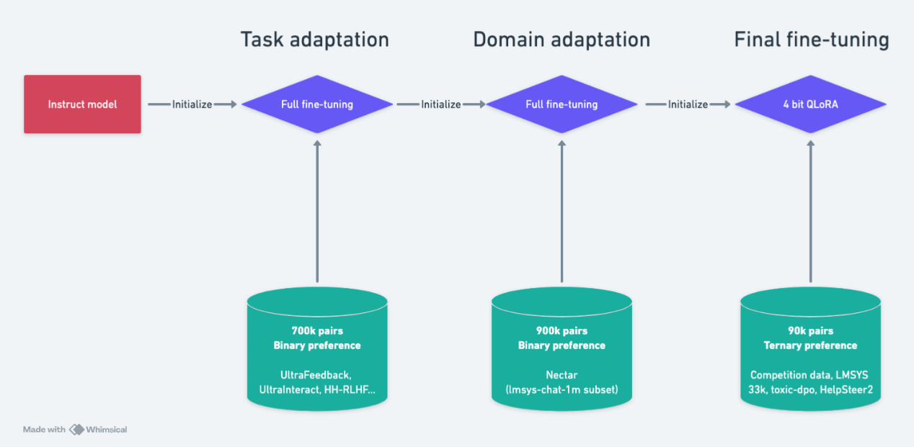
Task Adaptation Data
Inspired by the RLHFlow models, I utilized the datasets they preprocessed here.
Here is a summary of the datasets from their paper.
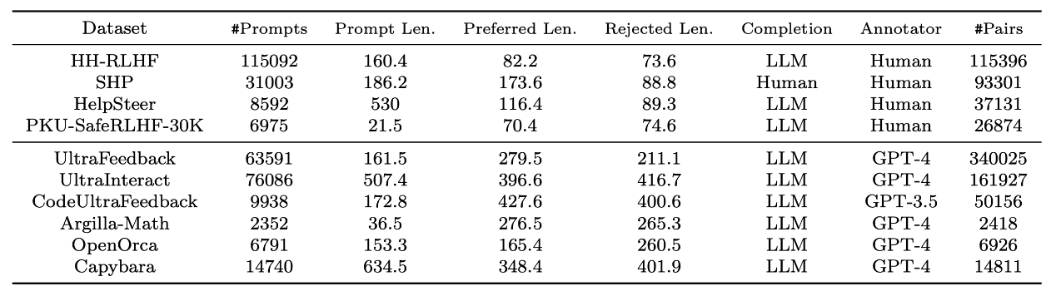
I excluded the SHP and PKU datasets. SHP due to containing human completions, and PKU because it is focused on safety, which is not a primary concern for the Chatbot Arena users.
The final task adaptation dataset consisted of approximately 700k binary preference pairs.
Domain Adaptation Data
For domain adaptation, I used the Nectar dataset, which includes prompts sourced from various resources, including the lmsys-chat-1m dataset. For each prompt, seven different completions were generated and ranked by GPT-4.
I used only the lmsys-chat-1m subset, yielding about 900k binary preference pairs.
Final Fine-tuning Data
For the final fine-tuning stage, I trained a ternary preference model utilizing all of the competition data as well as the following datasets, which I found beneficial at this stage:
- LMSYS 33k dataset
- toxic-dpo
  - This dataset consists of toxic but helpful answers versus rejection answers. I used the toxic answers as the correct ones.
  - My hypothesis was that the original Instruct models retained some of their “safe” behavior, even after fine-tuning with the competition data.
- Helpsteer2
  - To assign ternary labels, I used the “Helpfulness” score, as suggested by the authors (link).
  - I assigned a tie if the difference between scores was less than 1, and in other cases, I labeled the highest-scored model as the winner. I tuned this to ensure the label distribution resembled the competition label distribution.
I also applied deduplication across all stages without significant loss of data.
Eventually, I trained two models with slightly different data mixes.
Model Architecture
I experimented with various backbones and model sizes. I found that models in the 7B to 9B parameter range performed the best, with larger models providing only marginal improvements. Eventually, I settled on the meta-llama/Llama-3.1-8B-Instruct and google/gemma-2-9b-it backbones.
As noted by other competitors, Gemma’s high performance can be attributed to its training on LMSYS prompts (Gemma paper link). While I experimented with blending it with other backbones (such as Phi, InternLM, and Qwen), Llama 3.1 consistently delivered the best results.
I also implemented Multi-sample Dropout in the final classification head. While this technique is commonly used in NLP competitions with encoder architectures, I was surprised to find it effective with decoder LLMs as well. Although it resulted in a higher training loss, validation loss improved by approximately 0.005 across several experiments.
Prompting
I designed the prompt using the following strategy, which led to an approximate 0.01 total improvement in CV:
- Left Truncation
  - I truncated the input from the left (the start of the conversation). This is based on the fact that users typically evaluate models based on the end of the conversation, making the earlier part of the dialogue less relevant.
- Turn Alternation
  - Instead of passing the data in the format it was originally provided ([prompt_1, prompt_2, …] + [answer_model_a_1, answer_model_a_2, …] + [answer_model_b_1, answer_model_b_2, …]), I structured it turn by turn. This better simulates how a person would skim through conversation history. I passed the text in this format: [prompt_1, answer_model_a_1, answer_model_b_1] + [prompt_2, answer_model_a_2, answer_model_b_2] + ....
- Naive Instruction Prompt
  - Even though we fine-tune on a large dataset, I found that adding the following instruction prompt at the end sped up convergence and yielded slightly better results: Your task is to pick the best response between Model A and Model B or declare a Tie. Answer only with 'A', 'B', or 'Tie'. Think carefully before answering.
Positional Bias Mitigation
To minimize positional bias, I employed the following strategy:
- Train one model using the AB order, then predict using the BA order.
- Train another model using the BA order, then predict using the AB order.
- Combine the predictions by taking a weighted average of the outputs from both models.
I experimented with several other approaches to reformulate the task, such as regression and Siamese architectures, but these methods did not yield significant improvements.
Training Settings
- Loss Function
  - The loss function was a combination of cross-entropy (CE) and focal loss: Loss = CE * 0.7 + Focal * 0.3
  - I found focal loss to be beneficial in addressing the imbalance in the difficulty of the samples.
- LoRA Settings
  - Q, K, V, O projection layers
  - r=32, alpha=32
  - Used rsLoRA, which provided a significant performance boost of around 0.02 from the start so I continued using it.
- Scheduler
  - Cosine scheduler with a warmup of 10% of the total steps.
- Precision
  - bloat16
- Max Sequence Length
  - 1.8k tokens
- Optimizer
  - Adam optimizer with 8-bit precision
For hardware, I primarily used a single A100 GPU, occasionally switching to an H100. For larger pretraining runs, I utilized an H100x8 configuration a few times.
Inference Settings
- Attention
  - SDPA (Scaled Dot-Product Attention) since T4 GPUs do not support Flash Attention.
  - Note: The attention softcapping feature in the Gemma model was not compatible with SDPA, so I had to disable softcapping during training.
- Max Sequence Length
  - 1.8k tokens for one model and 4.1k tokens for the other
- Postprocessing
  - Temperature Scaling
    - I applied temperature scaling to the logits, tuning the temperature value based on the validation set.
  - "null" Answer Cases
    - For cases where one of the models gave a "null" answer, I assigned an equal probability of 1/3 to each label.
  - Refusal Postprocessing
    - If one model’s response contained phrases like “sorry,” “as an AI,” “apologize,” etc., I boosted the probability of the other model’s response by applying a coefficient of 1.05. Afterward, I renormalized the probabilities.
  - Renormalizing the Distribution
    - To maximize log loss performance theoretically, I renormalized the predicted probabilities to align the mean probability distribution of each class with the distribution observed during training.
- Efficiency
  - Mixed precision with torch.autocast
  - Sorted inputs by length
  - Split the test set in two and run inference on two GPUs in parallel
Here is a summary image of the training and inference setup:
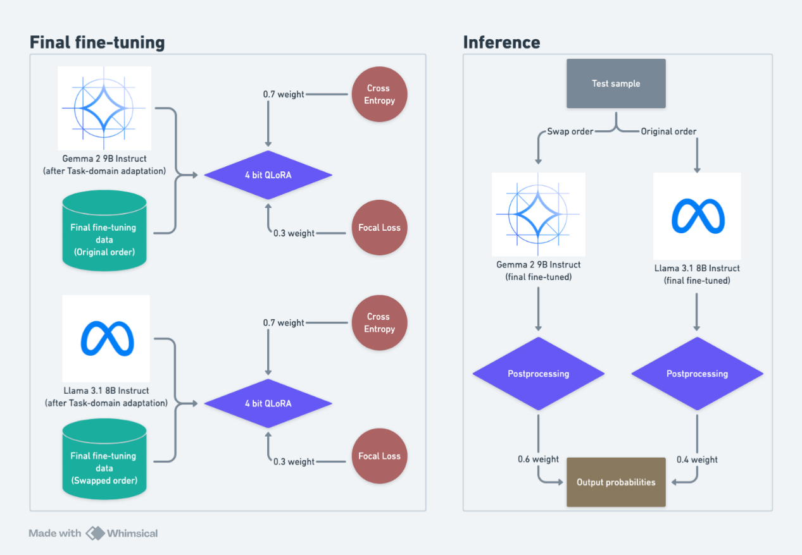
Unsuccessful experiments
There were a lot of unsuccessful tricks I tried so it is hard to list everything. I will try to include only the most interesting ones.
- Other PEFT settings apart from LoRA: DoRA, LoftQ etc.
- Adding more target layers in LoRA
- Optimizers like Lion or Sophia
- A lot pooling strategies including Max pooling, GRU pooling and more
- Layer freezing
- TF-IDF + LightGBM, Deberta blending
- Label smoothing
- Other training / inference speed-ups (Unsloth, vLLM, AWQ/GPTQ quantizations…)
  - Many are optimized for regular text generation so the speed up was not significant for this task
- Other datasets like Arena Hard, MT-Bench and more
- Other naive prompt experiments
- Language model pretraining on the prompts
- Adversarial training like AWP / FGM
- Knowledge distillation from Gemma 27B
  - Now I know I should have tried distilling from an ensemble of large models… (ref. 1st place solution)
- Stacking
- LoRA weight averaging, SWA, EMA…
- Pseudo-labeling
- Use ArmoRM labels as an auxillary regression loss
- Auxiliary model classification loss
- Mitigating the length bias by length based probability scaling
Thanks for reading and happy kaggling!
18th Place Solution
My approach did not use too many tricks; it involved some common strategies:
1. Training phase
Here, only the parts of the code that need modification are provided; the rest of the code strictly follows the publicly available Gemma 2 training scheme：https://www.kaggle.com/code/emiz6413/training-gemma-2-9b-4-bit-qlora-fine-tuning?scriptVersionId=187770530
`@dataclass
class Config:
output_dir: str = "output"
checkpoint: str = "unsloth/gemma-2-9b-it-bnb-4bit" # 4-bit quantized gemma-2-9b-instruct
max_length: int = 1024
n_splits: int = 800
fold_idx: int = 0
optim_type: str = "adamw_8bit"
per_device_train_batch_size: int = 4
gradient_accumulation_steps: int = 16 # global batch size is 8
per_device_eval_batch_size: int = 4
n_epochs: int = 1
freeze_layers: int = 0 # there're 42 layers in total, we don't add adapters to the first 16 layers
lr: float = 1e-5
warmup_steps: int = 20
lora_r: int = 64
lora_alpha: float = 32
lora_dropout: float = 0.05
lora_bias: str = "none"
config = Config()`
`lora_config = LoraConfig(
r=config.lora_r,
lora_alpha=config.lora_alpha,
# only target self-attention
target_modules=["q_proj", "k_proj", "v_proj","o_proj","gate_proj"],
layers_to_transform=[i for i in range(42) if i >= config.freeze_layers],
lora_dropout=config.lora_dropout,
bias=config.lora_bias,
task_type=TaskType.SEQ_CLS,
)`
2. Inference phase
I have already published the code for the inference part： https://www.kaggle.com/code/faykudbq/18th-inference-gemma2-max-length-2100-tta
Keypoints: Using a simple TTA method.
Note: Increasing the "max_length" often results in higher LB scores, but it can also lead to timeouts and is unstable (even if two identical setups are submitted, one might run successfully while the other could experience a timeout).
QA
      - May I ask for more details on the CV process: to obtain a trustworthy CV score, did you estimate the performance based on average scores from different folds, or did you use a separate holdout evaluation set?
I have tried both methods, and I prefer the latter.
      - Whether additional data was used？
Sorry, I forgot to mention this. I used an additional dataset of 33k.
19th Place Solution
key tricks
1. add o_proj, gate_proj to the target_modules in lora_config
lora_config = LoraConfig(
r=config.lora_r,
lora_alpha=config.lora_alpha,
target_modules=["q_proj", "k_proj", "v_proj", "o_proj", "gate_proj"],
layers_to_transform=[i for i in range(42) if i >= config.freeze_layers],
lora_dropout=config.lora_dropout,
bias=config.lora_bias,
task_type=TaskType.SEQ_CLS,
)
cv improve about 0.12
lb improve about 0.08(single model)
add : I will share the key experimental data in detail below.
2.improve training max_len to 3072
cv improve about 0.02
lb improve about 0.05(single model)
3.Set the number of frozen layers to 0
cv improve about 0.17
lb improve about 0.11(tta)
4.add external data
cv improve about 0.06
lb improve about 0.12(tta)
5.increase lora_r to 64
cv improve about 0.06
lb improve about 0.09(tta)
add if we stop here we can actual won a gold medal in the new test haha :)😄
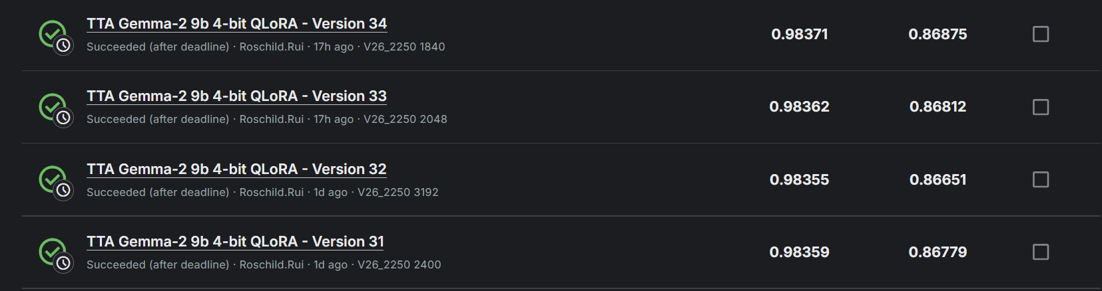
6.design a simple new header to replace the model.score
class CustomClassificationHead(nn.Module):
def __init__(self, config):
super().__init__()
self.fc1 = nn.Linear(config.hidden_size, config.hidden_size * 2, bias=False)
self.fc2 = nn.Linear(config.hidden_size * 2, config.hidden_size // 2, bias=False)
self.fc3 = nn.Linear(config.hidden_size // 2, config.num_labels, bias=False)

def forward(self, features):
x= self.fc1(features)
x= self.fc2(x)
x= self.fc3(x)
return x
cv improve about 0.03
lb improve about 0.04(tta)
Complete exploration process and key experimental data
Try deberta
The training and inferring notebook public here
Try Gemma-2-9B-it
Almost all the model weight i public here
and some in kaggle dataset
infer without head revised public here -> gold score haha :)
Gemma-9B-it key experiment data
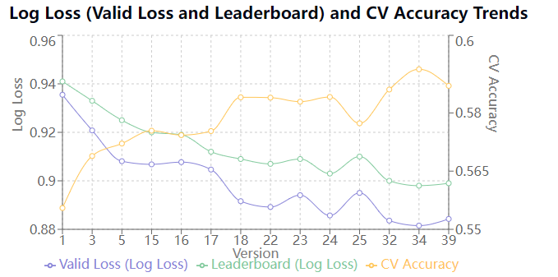
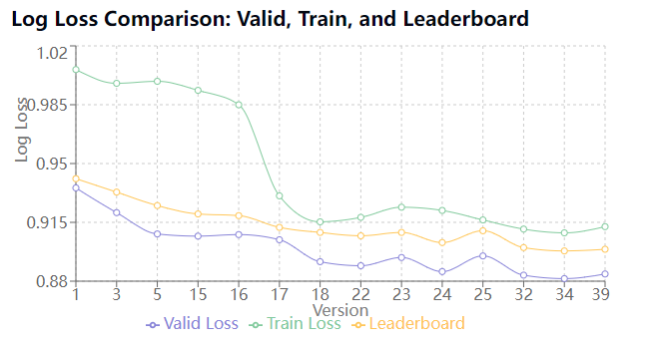
VER py_ver trick cv cv_acc train_loss lb n_epochs max_length bs gra_acc lr lora_r lora_alpha accelerator
1 1 original 0.935504 0.555498 1.005892 0.941 1 1024 4 2 2.00E-04 16 32 A100-40G
3 1 improve max_length 0.92079 0.568894 0.997738 0.933 1 2048 2 4 2.00E-04 16 32 A100-40G
5 4 add o_proj, gate_proj 0.908097 0.572112 0.998925 0.925 1 2048 8 4 2.00E-04 16 32 A100-80G
15 4 add o_proj, gate_proj+try long+inter 3072 0.906807 0.575418 0.993547 0.92 1 3072 2 8 2.00E-04 16 32 A100-40G
16 4 add o_proj, gate_proj+try long+freeze0+infer 3072 0.90772 0.574287 0.984961 0.919 1 3072 2 16 2.00E-04 16 32 A100-40G
17 mixed data+add o_proj, gate_proj+try long 0.904647 0.575331 0.930781 0.912 1 3072 2 16 1.00E-04 16 32 A100-40G
18 mixed data+add o_proj, gate_proj+try long+freeze0 0.891603 0.584029 0.915302 1 3072 2 16 1.00E-04 16 32 A100-40G
22 mixed data+add o_proj, gate_proj+try long+freeze0+increase r 0.889211 0.583942 0.917987 1 3072 2 16 1.00E-04 32 64 A100-40G
23 mixed data+add o_proj, gate_proj+try long+freeze0+increase r 0.894082 0.582898 0.924007 1 3072 2 16 1.00E-04 24 48 A100-40G
24 mixed data+add o_proj, gate_proj+try long+freeze0+increase r 0.885727 0.584116 0.92209 1 3072 2 16 1.00E-04 48 96 A100-40G
random tta v18 0.906 3072
v18 tta 0.908 2048
v17 cp2000 tta 0.919 1536
v18 cp2000 tta 0.911 1536
v18 cp2000 tta 0.906 2000
v18 cp2000 tta 0.906 2100
v21 cp2100 0.913 3072
v21 cp2100 tta 0.905 2000
particular tta 0-1024 non tta 0.91
particular tta 0-1536 non tta 0.91
25 lora_alpha = 32 +mixed data+add o_proj, gate_proj+try long+freeze0+increase r 0.895018 0.577331 0.916444 1 3072 2 16 1.00E-04 64 32 A100-40G
26 n_split = 10+mixed data+add o_proj, gate_proj+try long+freeze0+increase r 0.869383 0.591336 0.925077 1 3072 2 16 1.00E-04 48 96 A100-40G
27 n_split = 50+mixed data+add o_proj, gate_proj+try long+freeze0+increase r 0.858467 0.607826 0.933301 1 3072 2 16 1.00E-04 64 128 A100-40G
28 new mixed data+add o_proj, gate_proj+try long+freeze0+increase r 0.593338 0.758525 0.844598 1 3072 2 16 1.00E-04 64 128 A100-40G
29 n_split = 100+mixed data+add o_proj, gate_proj+try long+freeze0+increase r 0.832338 0.615652 0.929202 1 3072 2 16 1.00E-04 64 128 A100-40G
30 continue train based on v29 cp2440 0.828129 0.626087 0.898
32 new_score_head n_split = 5 0.883596 0.58603 0.910986 1 3072 2 16 1.00E-04 64 128 A100-40G
33 new_score_head n_split = 10 0.869587 0.598643 0.91562 1 3072 2 16 1.00E-04 64 128 A100-40G
v26_2250 0.895 2000
v26_2200 0.896 1900
v27_2200 0.899 1920
v27_2200 0.903 1536
v29_2440 tta 0.894 1776
34 new head + alpha = r 0.881545 0.591249 0.908757 1 3072 2 16 1.00E-04 64 64 A100-40G
35 new head + alpha = r n_split = 10 1 3072 2 16 1.00E-04 64 64 A100-40G
36 attn head + alpha = r 1 3072 2 16 1.00E-04 64 64 A100-40G
37 linear head+ bf16 + eager n_split = 10 1 3072 2 16 1.00E-04 64 64 A100-40G
38 linear head+ bf16 + eager n_split = 50 0.858054 0.606957 0.911753 1 3072 2 16 1.00E-04 64 64 A100-40G
39 linear head+ bf16 + eager n_split = 5 0.884285 0.586987 0.912451 1 3072 2 16 1.00E-04 64 64 A100-40G
40 ipynb+n_split = 10+mixed data+linear head+ bf16 + eager 0.840444 0.619868 0.934066 1 3072 2 16 1.00E-04 64 64 A100-40G
41 ipynb+n_split = 100+mixed data+linear head+ bf16 + eager 0.831409 0.636522 0.915951 1 3072 2 16 1.00E-04 64 64 A100-40G
42 ipynb+n_split = 5+mixed data+linear head+ bf16 + eager 0.842306 0.612661 0.925324 1 3072 2 16 1.00E-04 64 64 A100-40G
v38_2422 tta 0.892 2048
mix_data : comp data +21k external data

Try Llama3.1-8B-it
i have changed a padding token. Download the new complete revised model file and trained weight at here
training scripts
Llama3.1-8B-it experiment data
VER py_ver trick cv cv_acc train_loss lb n_epochs max_length warmup_steps warm_radio bs gra_acc lr lora_r lora_alpha lora_dropouut lora_bias accelerator
1 1 original 0.981412351 0.516527488 1.06309152 1 2048 20 0 4 8 2.00E-04 16 32 0.05 none A100-40G
2 1 improve max_len 0.976300371 0.522442589 </td> 1 3072 20 0 2 8 2.00E-04 16 32 0.05 none A100-40G
3 2 sft 0.931414843 0.555671538 0.974404319 1 3072 20 0 2 8 1.00E-04 16 32 0.05 none A100-40G
4 2 sft+mix_data 0.921216846 0.562021573 0.924224623 1 3072 20 0 2 8 1.00E-04 16 32 0.05 none A100-40G
5 2 sft+mix_data+o_proj+gate_proj 0.922720075 0.564631176 0.924524553 1 3072 20 0 2 8 1.00E-04 16 32 0.05 none A100-40G
6 2 sft+mix_data+o_proj+gate_proj+dense 0.920885503 0.561325678 0.924782057 1 3072 20 0 2 8 1.00E-04 16 32 0.05 none A100-40G
mix_data : comp data +21k external data
Potential optimization points and unresolved issues
Potential optimization points
1.left truncation
2.Use 8-bit to accelerate inference
3.Add two prediction heads to predict which two models provided response_a and response_b
4.EMA
5.more strong related data
Unresolved issues
1.Two stages fine-tuning struggles to converge
2.knowledge distillation hard to find a good method
3.hard to ft full parameters to get a good cv result
4. @mohammad2012191 public here
QA
      - Sorry for missing the gold medal - you still achieved a great score! I am not sure if there is a lesson to be learned here, if your experiments improved on both public lb and cv, it seems reasonable to go forward with these gains. It might just be the too small new test dataset that got you in the end.
Yeah it was a close one! I think if we tried left truncation and a second model with flipped inputs instead of TTA I think we would have been in. Next time maybe! Haha it was a great team!

